11.24: a) The strain, from Eq. (11.12), is 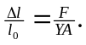For steel, using Y from Table (11.1)
and 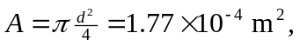
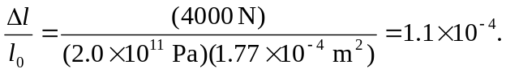

Similarly, the strain for copper 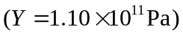 is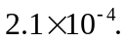b) Steel: 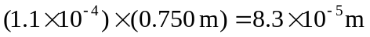. Copper: 